Course: Data Science Roll No: TYCS-12

Aim: Practical on Decision Tree.

__________________________________________________________________________________

Output 1

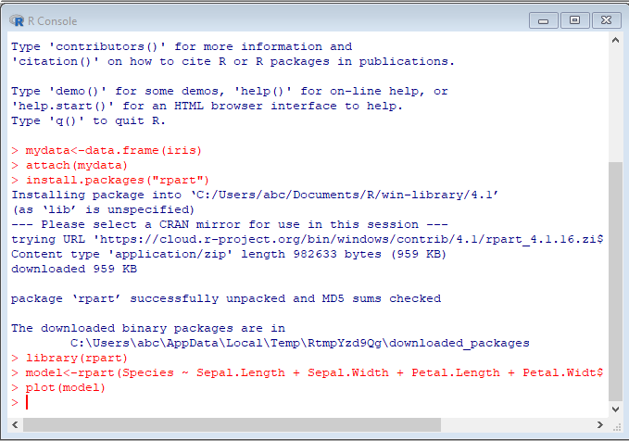Output 2

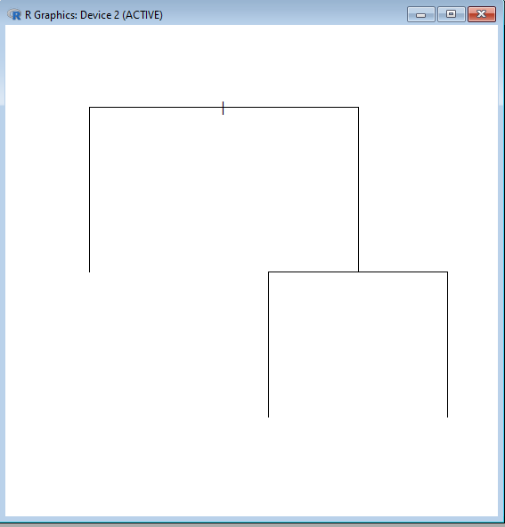

Output 3

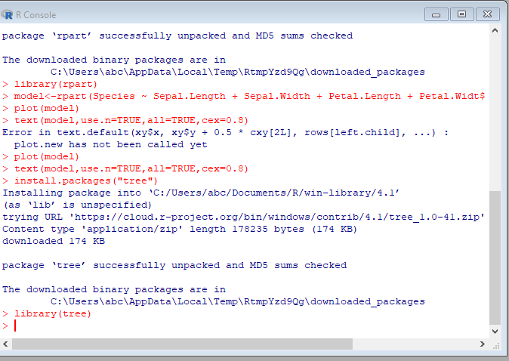Output 4

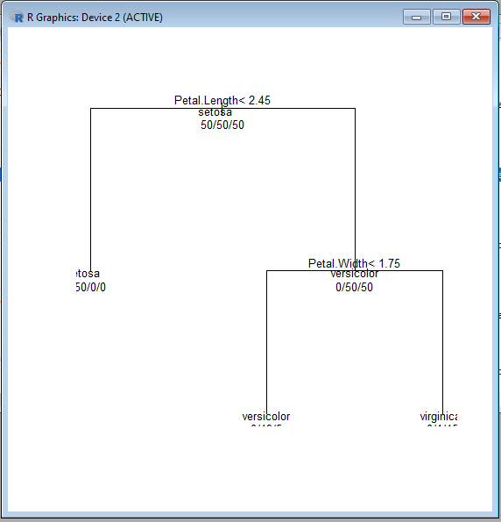

Output 5

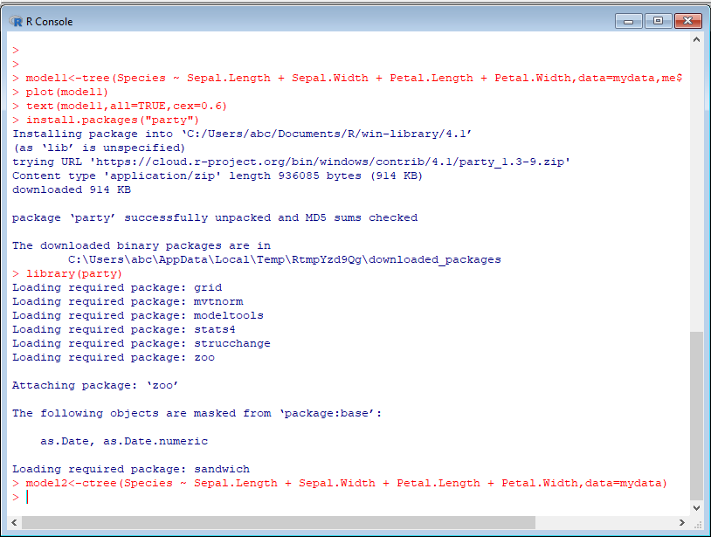Output6

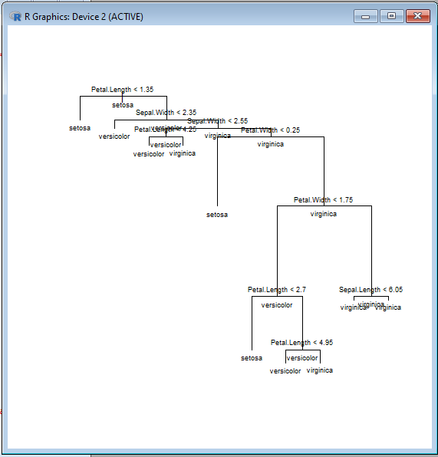

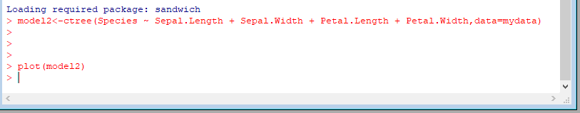

Output 7

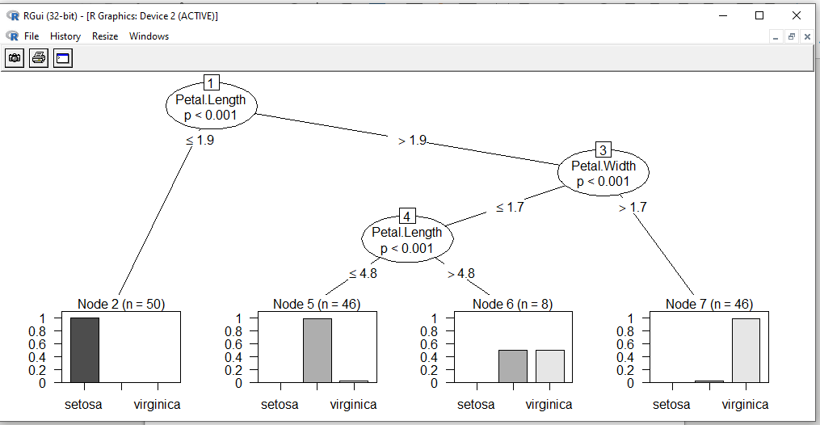Output 8

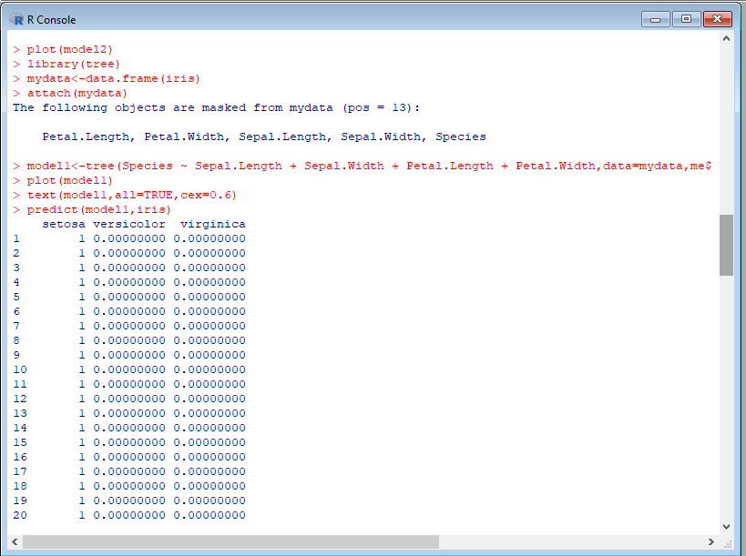

Output 9:

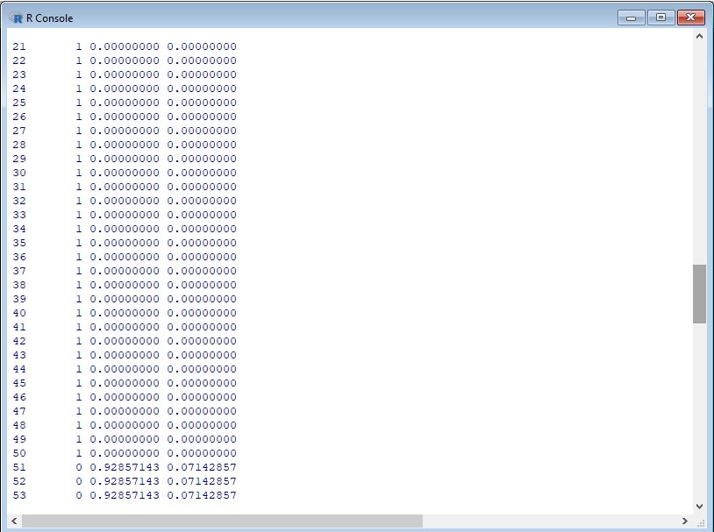

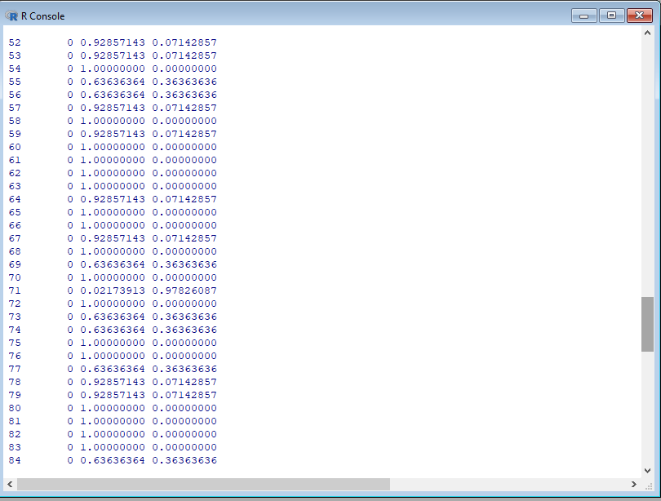

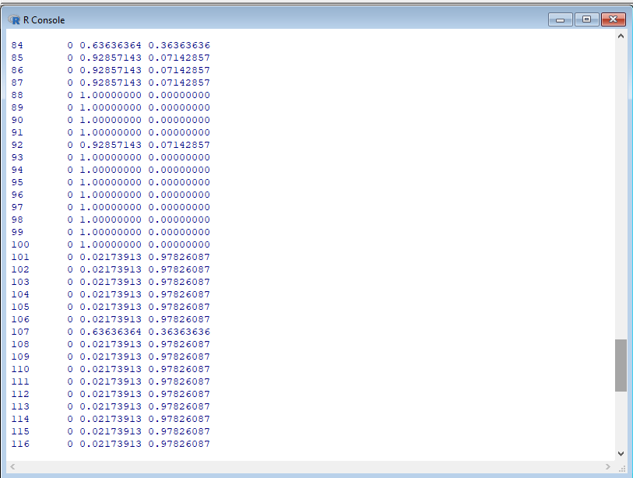

Output 10

